EXPERIMENT 2: Simulation of Density of States of Quantum Well Structure with
Various Nanometer Thickness.

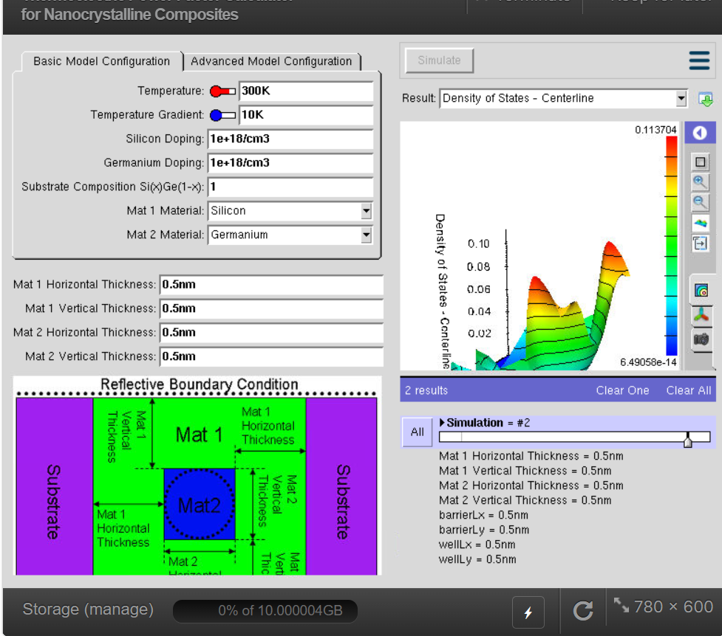
This project is done to study how the thickness of a quantum well affects the Density of States (DOS). When the quantum well becomes very thin (a few nanometers), electrons are confined, and their energy levels change. By simulating different thicknesses, we can understand how electrons behave in nanostructures and improve the design of semiconductor devices like LEDs, lasers, and transistors.

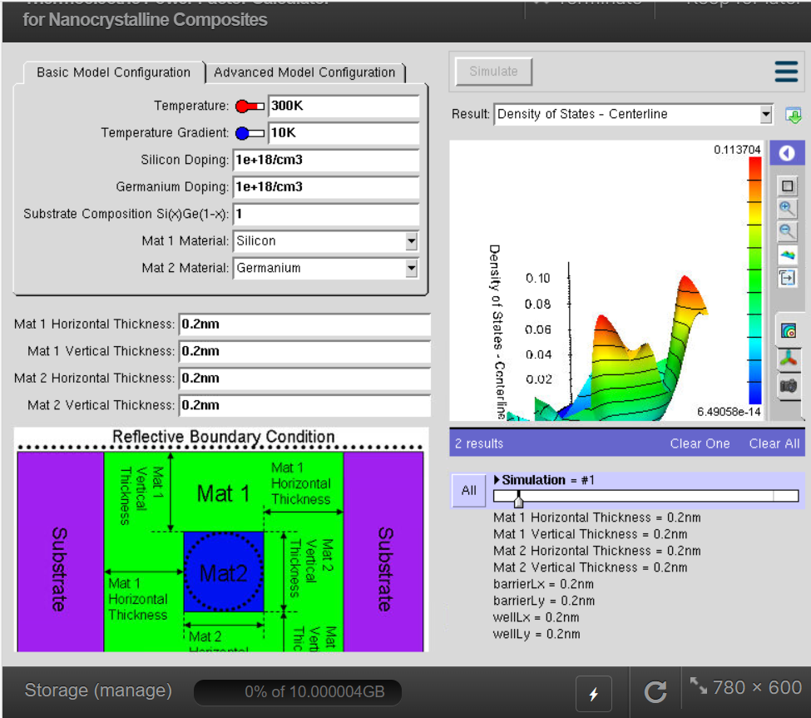
CASE STUDY 1: Simulate the density of states of quantum well of thickness 0.2 nm

A 0.2 nm quantum well is extremely thin, so electrons are strongly confined. This strong quantum confinement produces widely spaced discrete energy levels and significantly changes the Density of States (DOS) compared to thicker quantum wells.

CASE STUDY 2:
Simulate the density of states of quantum well of thickness 0.6 nm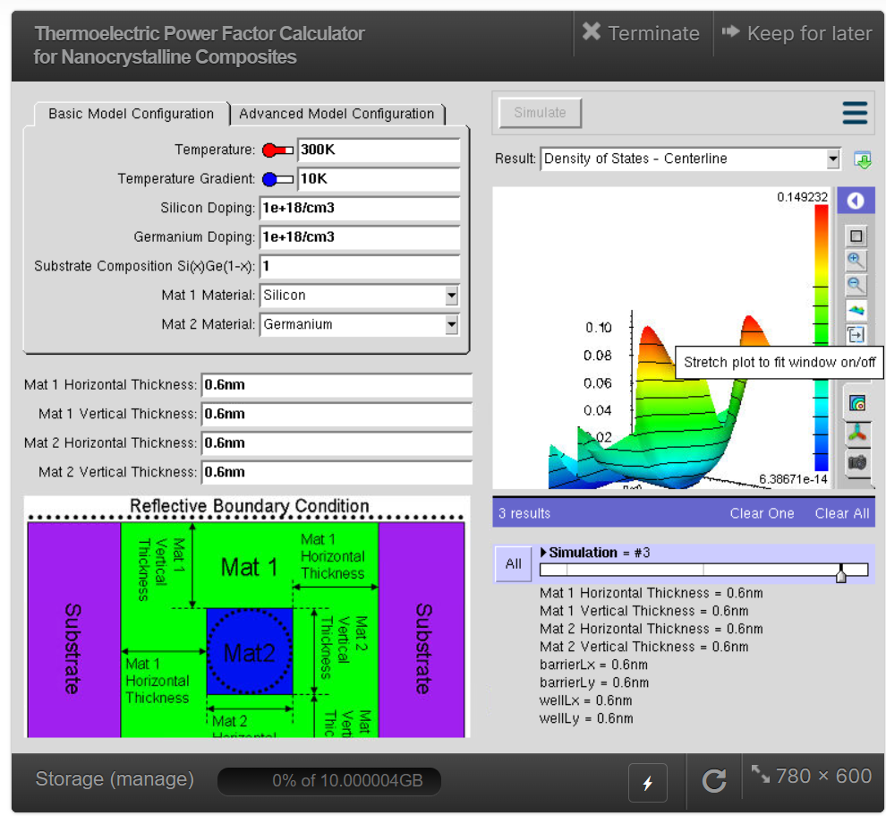

A 0.6 nm quantum well is thicker than a 0.2 nm well, so the quantum confinement is weaker. Simulating this thickness helps study how increasing the well thickness changes the Density of States (DOS) and electron energy levels

